
HEALTHCARE ANALYTICS / FRAUD, WASTE & ABUSE
Healthcare Provider
Fraud Risk Explorer
Turning claims data into a prioritized, explainable investigation pipeline
Akash and Shruthi | Project report | June 2026

At a Glance
The 60-second version before the detail.
- What we are building: a Provider Fraud Risk Explorer that ranks providers by fraud risk and explains every flag, so investigators review the few cases most likely to be real.
- Unit of decision: the provider (not the claim), because that is what gets labeled, investigated, and budgeted.
- Metric that matters: precision in the top 1 to 5 percent, not overall accuracy. We optimize the slice an analyst can reach.
- How: clean and link claims, build peer-relative features, run a supervised plus an anomaly model, rank, and ship an explainable queue.
- Why it is not a regular project: graph collusion-ring detection, a synthetic fraud simulator, an LLM agent that writes the case file, an ROI simulator, and a red-team evasion test.
- Cutting edge: GNN embeddings, an agentic RAG investigator, conformal confidence, generative augmentation, all grounded in 2024 to 2026 papers.
KEY POINT Bottom line for us: this is a fraud intelligence platform, not a notebook. The rest of this document is the full design, the exhibits, and the research behind it.

Executive Summary
Payers lose several cents on every healthcare dollar to fraud, waste, and abuse, yet investigation capacity is fixed and scarce. The highest-value move is not to detect all fraud. It is to rank the limited set of providers an investigator can actually review each week, and explain why each one is on the list.
We are building a Provider Fraud Risk Explorer: a workflow that converts raw claims into provider-level risk scores, ranks providers into an investigation queue, and gives every flag a transparent, peer-relative explanation. The design is built around the investigator's constraint, not a model's accuracy in isolation.
- The unit of decision is the provider, not the claim. Labels, budgets, and enforcement all operate at provider level.
- Precision at the top is the metric that matters. The top 1 to 5 percent must be dense with true fraud.
- An unexplained flag is an unusable flag. Every score must decompose into peer comparisons and feature drivers.
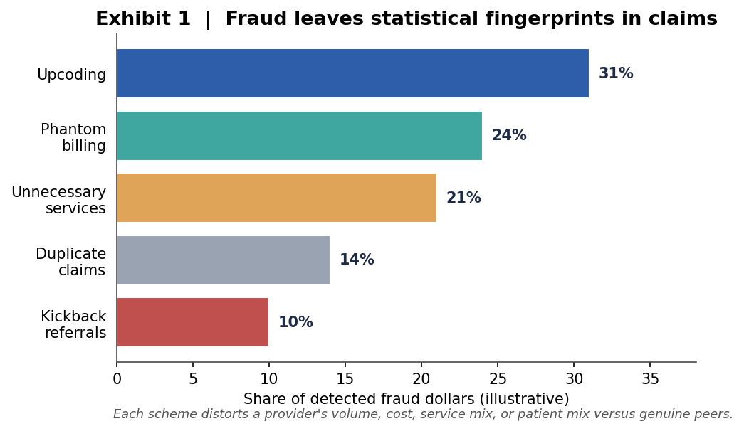

1. The Problem: Capacity, Not Detection, Is the Constraint
Healthcare fraud consumes an estimated several percent of total health spending, and the dominant schemes leave statistical fingerprints in claims. Each scheme distorts a provider's volume, cost, service mix, or patient mix relative to genuine peers. That distortion is what we measure.
KEY POINT Detection models are abundant. Investigator hours are not. The binding constraint is the cost of human review, which reframes the whole objective into a prioritization problem.
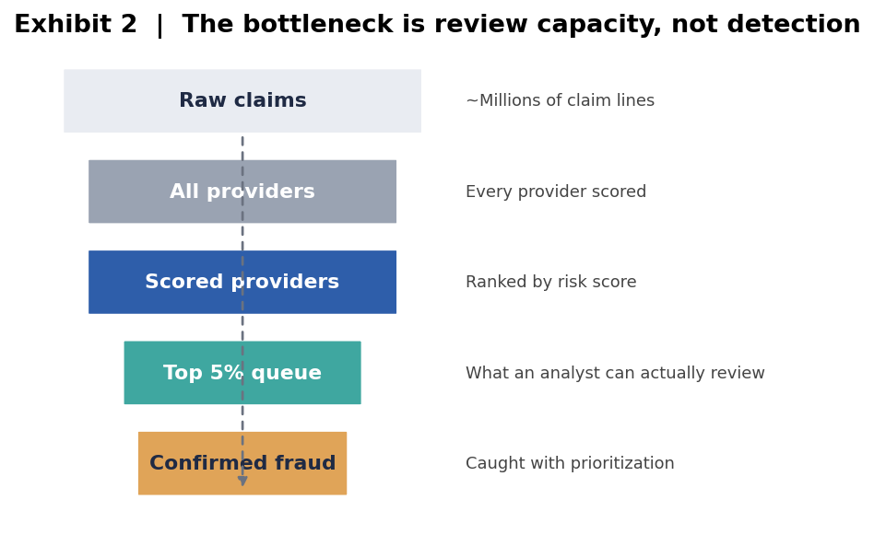

2. The Data: Provider-Level Labels Make This Tractable
The build is anchored on the labeled Kaggle Healthcare Provider Fraud Detection dataset, which provides what most claims data lacks: a provider-level fraud label across four linkable tables.
Table | Content | Role
Beneficiary | Demographics, chronic conditions | Patient-mix features
Inpatient claims | Reimbursements, length of stay, codes | Volume, cost, intensity
Outpatient claims | Reimbursements, procedure codes | Volume, cost
Provider labels | PotentialFraud flag per provider | Supervised target

CMS DE-SynPUF (2008 to 2010) is a synthetic Medicare 5 percent sample used as a supplementary source. It is synthetic with no fraud labels, so it serves the anomaly and engineering track, not supervised training (see the included SynPUF user manual for its data dictionary).

3. How We Build It: From Claims to a Ranked, Explained Queue
PHASE A / DATA FOUNDATION
First we clean and link the four tables into one provider-keyed dataset. Cleaning is deliberately conservative: in fraud data the outliers are the signal, not the noise, so we fix types and clearly broken values but never smooth away genuine extremes.
PHASE B / FEATURE ENGINEERING
Two layers of features. Describe each provider, then position each provider against peers. The second layer is what makes the system work: the same behavior can be normal in one specialty and fraudulent in another.
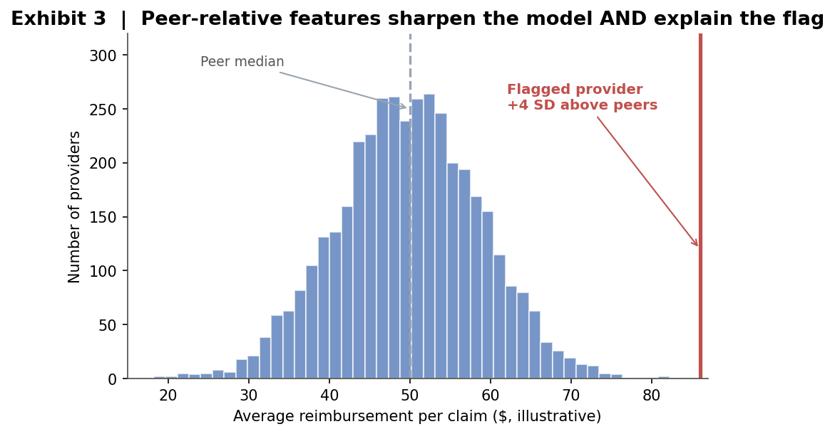
KEY POINT Peer-relative features do double duty. They sharpen the model and pre-build the explanation: 'bills 4 standard deviations above peer average for procedure X'.
PHASE C / MODELING: TWO TRACKS, TWO JOBS
Supervised and unsupervised models are not competitors. They cover different failure modes. Supervised models reproduce known fraud; anomaly models surface providers who look wrong but were never labeled, which is exactly where new schemes hide.
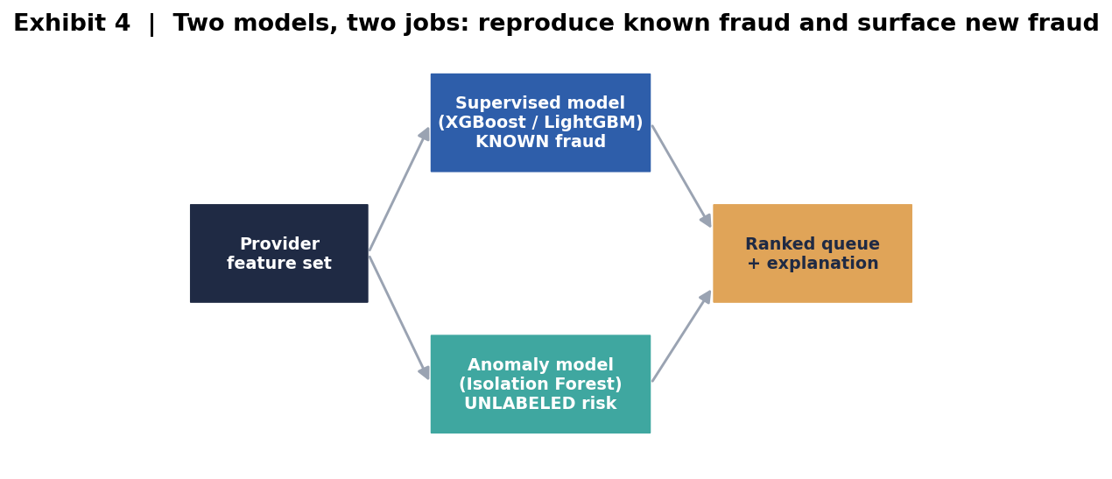

4. Evaluation: Optimize for the Investigator's Budget
Standard metrics are reported, but ranked by relevance to the use case. An investigator with capacity for the top 5 percent does not care about performance in the bottom 95 percent.
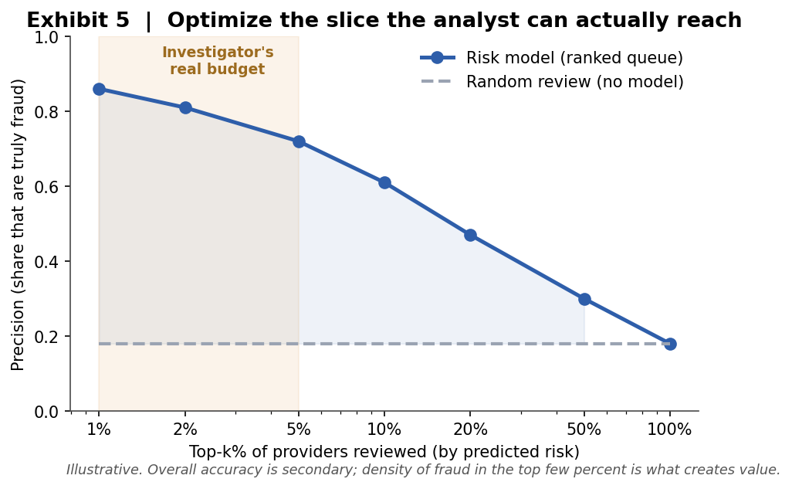
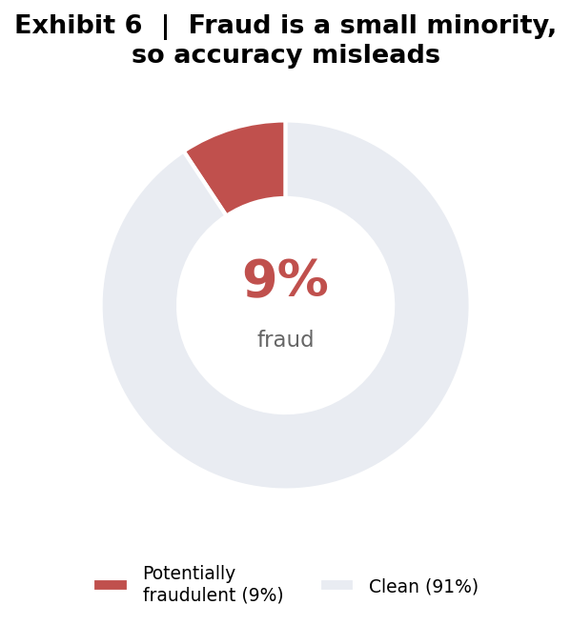
Metric | What it answers | Priority
Precision at top-k | Of who we review, how many are real fraud? | Primary
Precision / Recall | How clean and complete are flags? | Supporting
F1 | Balanced single number | Supporting
ROC AUC | Overall ranking ability | Context

5. The Risk Explorer and Explainability
A model in a notebook changes nothing. Value is created the moment an investigator opens a queue and knows what to do. The Explorer surfaces a ranked table, a per-provider detail view, filters, and most importantly, the reasoning behind every flag.
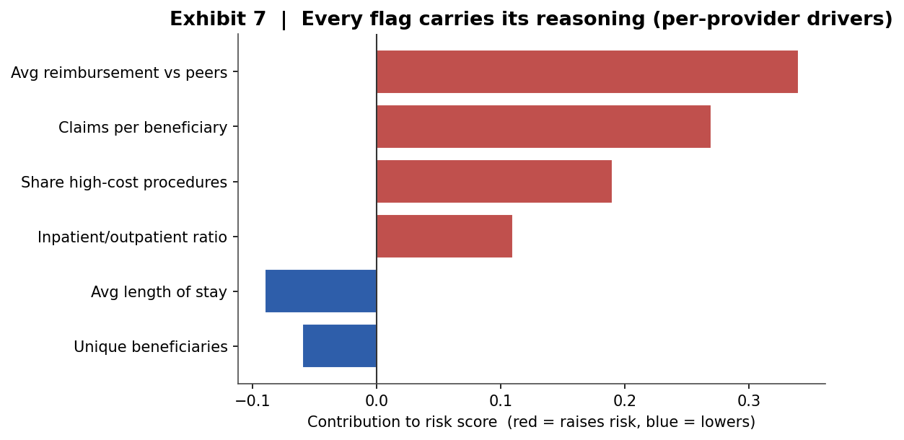
KEY POINT Because a false positive can damage a legitimate provider, every flag must carry its reasoning. Without explanations the queue is just a list nobody acts on.

WHAT MAKES THIS MORE THAN A PORTFOLIO PROJECT
6. From Classifier to Fraud Intelligence Platform
A typical project loads data, trains a model, and reports a score. We go five steps further. Each move below is independently impressive, and together they tell one story: this is not a notebook, it is a system that thinks like an investigator.
6.1 Collusion ring detection (graph analysis)
Real fraud is often organized, not solo. We build a provider-to-beneficiary network and detect rings of providers who share the same patients and cross-bill each other. Community detection (Louvain) and node embeddings (Node2Vec) expose structure that row-by-row models are blind to.
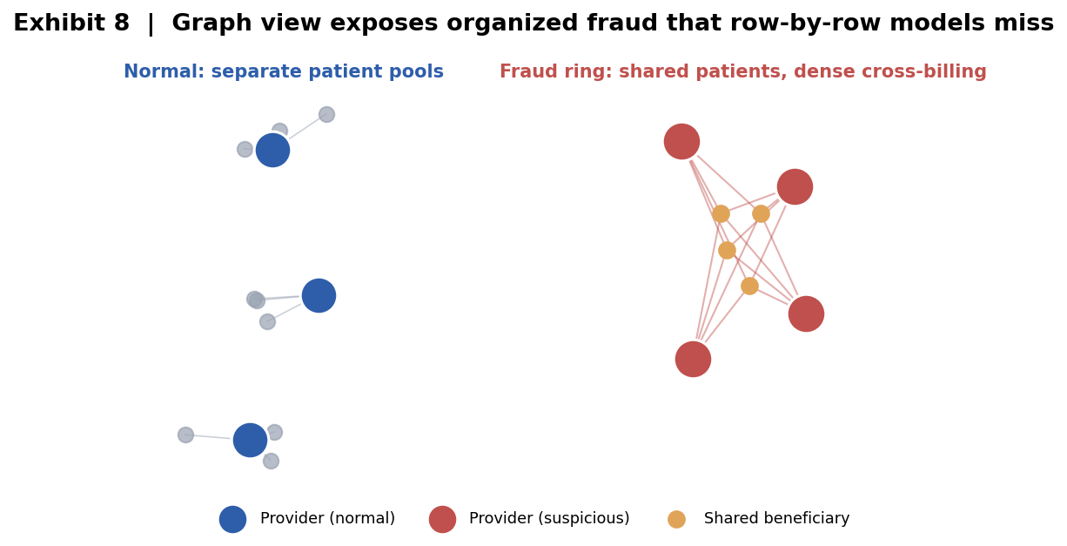
6.2 Synthetic fraud injection simulator
SynPUF has no fraud labels, so we inject our own. We take clean providers and synthetically apply known schemes (upcoding, phantom billing, patient sharing) with ground truth we fully control, then prove our detectors recover them. This is rigor almost no portfolio project demonstrates: we can measure detection rate against a fraud pattern we designed.
6.3 An LLM agent that writes the case file
We attach a Claude-powered agent that reads a flagged provider's statistics and drafts a plain-English Suspicious Activity Report: why this provider was flagged, which peers it deviates from, and what an investigator should check next. It turns a risk score into an investigator-ready narrative in seconds.
6.4 Budget and ROI decision simulator
An interactive slider for 'how many investigator-hours do I have this week' that outputs the expected dollars of fraud recovered and the marginal return of one more reviewer. This reframes the project from a model into decision support that a finance leader would actually use.
6.5 Red-team evasion test
We play the fraudster. We simulate a provider slowly drifting their billing to dodge detection, then show that peer-relative and anomaly features resist the evasion where a naive model fails. A security mindset applied to fraud analytics, which is rare and memorable.
KEY POINT The headline: we are not submitting a fraud classifier. We are shipping a fraud intelligence platform with graph reasoning, a fraud simulator, an AI analyst, and a decision tool.

ADVANCED TRACK / CURRENT METHODS, NOT TEXTBOOK ONES
7. Cutting-Edge Techniques
These are the 2025 to 2026 methods that signal we are building at the frontier, not following a tutorial. Each maps to a specific weakness of the standard approach.
7.1 Graph Neural Networks for fraud-aware embeddings
Hand-built features cannot see network structure. We train a GraphSAGE or Graph Attention Network on the provider-beneficiary graph so each provider gets a learned embedding that encodes who it bills with. Providers then get flagged for sitting near known fraudsters in embedding space, even with no obvious individual red flag. GNNs are the current state of the art in financial fraud detection.
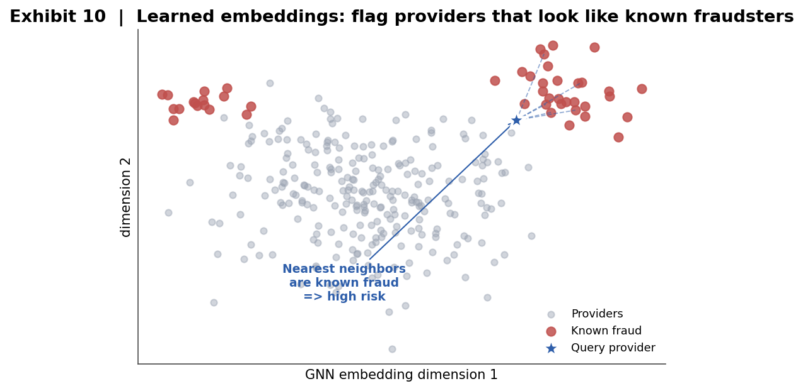
7.2 Agentic LLM investigator with tool use and RAG
Beyond writing a summary, the Claude agent runs a workflow: it queries a provider's graph neighbors, compares peers, retrieves the relevant CMS and OIG billing rules (retrieval-augmented generation), and produces a grounded recommendation to escalate or dismiss with a cited rationale. The reasoning is anchored in real policy, not model intuition.
7.3 Conformal prediction for calibrated trust
A raw probability is not a guarantee. Conformal prediction wraps every score in a statistically valid confidence level, so the queue can tell an investigator which flags are high-confidence and which are borderline. This is one of the hottest areas in trustworthy ML and it directly serves the use case.
7.4 Tabular diffusion to generate synthetic fraud
Fraud is rare, so we augment it. Modern tabular generative models (CTGAN and tabular diffusion) synthesize realistic fraudulent providers to balance training without naive oversampling, improving recall on the rare class while preserving the data distribution.
7.5 Vector search and active learning loop
Provider embeddings live in a vector database, enabling instant 'find me providers most similar to this known fraudster' queries. An active learning loop then asks the investigator to label the model's most uncertain cases and retrains, so the system gets sharper with every review instead of going stale.
KEY POINT GNN embeddings, an agentic RAG investigator, conformal confidence, generative augmentation, and an active-learning loop. This is a research-grade stack applied to a real, gritty problem.

GROUNDED IN CURRENT LITERATURE, 2024 TO 2026
8. Research Foundation
Every design choice above is backed by recent peer-reviewed work. The numbers and methods below are drawn from current systematic reviews and primary papers.
8.1 The problem is real and large
- An estimated 3 to 10 percent of US healthcare spending, roughly 300 billion dollars per year, is lost to fraud (systematic review, Artificial Intelligence in Medicine, 2025).
- Surveys consistently name three hard problems: class imbalance, scarce labels, and model interpretability. Reviews explicitly call for explainable AI as the priority direction.
8.2 What the field is actually doing
A 2025 Journal of Big Data review of 22 techniques (Dec 2017 to Oct 2024) splits the field into supervised (deep learning, graph-based, meta-learning), unsupervised, and semi-supervised. Our two-track plus graph plus LLM design sits squarely on the current research frontier.
Our technique | Backed by | What the paper shows
Graph / GNN ring detection | Sci. Reports 2025; Heliyon 2024 (MHGSL) | Model patients, providers, claims as a heterogeneous graph; GNNs beat flat models and add explanation
LLM investigator agent | FAA Fraud Analysis Agent, arXiv 2506.11635 (2025) | LLM agent runs multi-step investigation and writes human-readable reports, not just a label
Conformal confidence | ITCF framework, Technologies 2025 | Conformal abstention plus entropy routes ambiguous cases to humans for triage
Generative augmentation | GAN attack study, arXiv 2506.19871 (2025) | Generative models stress-test and augment fraud detectors on medical claims
Unsupervised anomaly | Unsupervised provider anomaly detection, PMC7134221 | Flags providers diverging from peers without labels

KEY POINT Takeaway: our 'crazy' features are not speculative. Graph neural networks, LLM investigation agents, and conformal uncertainty are exactly where 2025 to 2026 fraud research is heading.
8.3 Key references
- Fraud detection in healthcare claims using machine learning: a systematic review. Artificial Intelligence in Medicine, 2025. doi:10.1016/j.artmed.2024.103061
- A review of distinct machine learning classifiers for healthcare fraud detection. Journal of Big Data, 2025. doi:10.1186/s40537-025-01295-3
- Fraud detection and explanation in medical claims using GNN architectures. Scientific Reports, 2025. doi:10.1038/s41598-025-22910-6
- Health insurance fraud detection based on multi-channel heterogeneous graph structure learning (MHGSL). Heliyon, 2024. PMC11061682
- Shuster et al. FAA: a large language model-based fraud analysis agent. arXiv:2506.11635, 2025
- Integrating model explainability and uncertainty quantification for trustworthy fraud detection (ITCF). Technologies, 2025. doi:10.3390/technologies14040212
- An attack method for medical insurance claim fraud detection based on GANs. arXiv:2506.19871, 2025
- Unsupervised anomaly detection of healthcare providers using generative adversarial networks. PMC7134221

9. Roadmap and Learning Outcomes
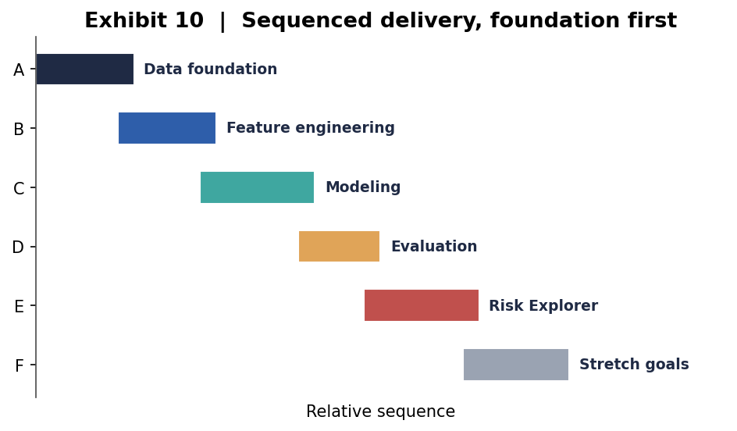
Skills this project lets us demonstrably claim:
- Framing a vague goal into the real operational constraint
- Multi-table healthcare claims wrangling into a provider view
- Peer-benchmarked feature engineering, the core of fraud analytics
- Imbalanced classification and unsupervised anomaly detection
- Graph and network analysis for organized fraud
- Model explainability with SHAP and counterfactuals
- LLM agents applied to a real analytics workflow
- Ethics, fairness, and human-in-the-loop design for high-stakes ML

